EXCERCISE NUMBER :3

DATE :12/10/2020

AIM:

Python program to remove and print every second number from a list of numbers until the list becomes empty .

Programs :

def remove(list):

temp=[]

p=1

s=0

for i in range(0,len(list)):

s=(p+s)%len(list)

el=list.pop(s)

temp.append(el)

return temp

n=int(input())

list=[]

for i in range(0,n):

list.append(int(input()))

a=remove(list)

print(a)

Link :

<http://103.53.53.18/mod/vpl/forms/edit.php?id=231&userid=1787#>

Output:

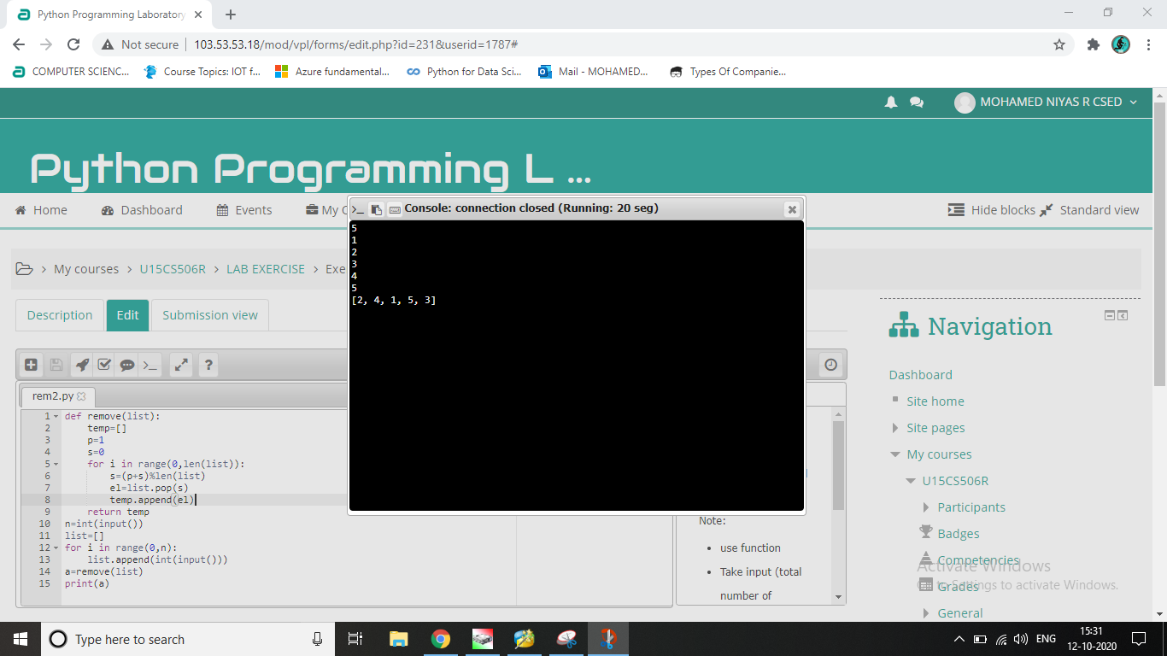

Result:

The program is executed correctly